THE CHALLENGES OF WIRELESS COMMUNICATIONS
IN DEVELOPING A VIRTUAL UNIVERSITY

P.M.Papazoglou
Lecturer
papaz@teilam.gr
Department of Informatics and Computer Technology
Lamia Institute of Technology
Lamia, Greece
D.A.Karras
Associate Professor
Department of Automation Engineering
Chalkis Institute of Technology
Psachna, Greece
A.C.Tsakiri
MSc candidate
University of Paisley

ABSTRACT
The e-learning concept exists for many years but only lately applied successfully due to technology evolution. The distance learning courses became true when the communication technology reached an acceptable level of services. The user demand for advanced services such as video telephony, file transfer and real time multimedia communication, supports the idea of the virtual University which offers full educational services to moving users via wireless access. Due to the needed advanced services the efficient bandwidth management is a major issue. The technology of mobile cellular networks constitutes a guide for implementing and offering advanced mobile multimedia services. Through this paper we present the trends of e-learning in higher education in combination with the technical challenges in the area of wireless communications (specifically in cellular networks) such as channel allocation strategies for implementing the needed services.

KEYWORDS
e-learning, e-University, Mobile multimedia communications, technical challenges

INTRODUCTION
Emerge of E-learning for most of the people means the replacement of some traditional educational procedures with electronic ones based on network technology. E-Learning is a broad term, intended to include many and different ways that technology might be used in order to support and enhance a student's learning experience. Effective E-Learning systems increasingly integrate digital resources and media in order to offer the needed educational frame with proper quality. There is now a wealth of digital resources, information and communication technology tools to support e-learning [1]. Today, popular software tools are the implementation of the e-learning systems [2]. Extending the basic idea of e-learning we can talk about virtual University and e-University. In e-University the educational services are offered via internet whereas in Virtual University the services are completely offered in distance [3]. The Virtual University offers high flexibility by supporting wireless access to mobile users. The wireless access of the mobile users introduces major problems such as restricted bandwidth, Quality of service, etc, found in the field of wireless communications (e.g. cellular communications). We can access virtual University services using mobile technology from any place in the world. The implementation of a Virtual University can be faced from three different points of view which are

- Pedagogical and Social issues
- Technological aspects
- Financial matters

Pedagogical and social issues refer to cognitive gain, optimization of goal achievement, development of collaborative environments, positive social impact of the applied method, etc. Technical challenges (especially in wireless communications) in combination with development and implementation methodologies for the virtual University constitute major aspects of the technological side. Financial maters like budget availability are also key points for the virtual University. Many universities increase the number of students and in the same time try to keep down their budget [4]. There are many major challenges in supporting wireless multimedia services such as:

- Spectrum limitations
- Multipath propagation (signal transmission over different paths)
- Quality of Service assurance for the multimedia services (especially in real time applications)
- Energy limitations (mobile device operational autonomy)
- User mobility (area coverage, user velocity, etc)

TRENDS OF E-LEARNING IN HIGHER EDUCATION

Several studies for the contribution of e-learning in higher education in Greece and for e-learning systems development have been made[5,6]. The following figures present graphically the trends of e-learning with regard to students opinion of the department of Informatics and Computer Technology of Lamia Institute of Technology.
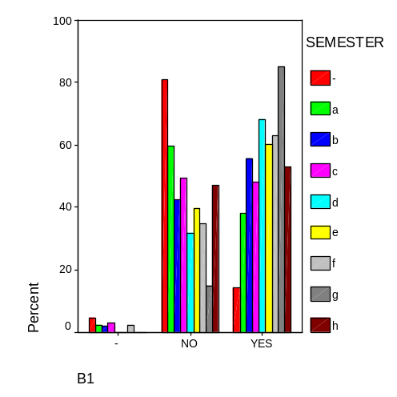
Fig. 1 students’ prior knowledge on e-Learning.

Fig. 1, illustrates that students of higher semesters are better informed about e-Learning than students at the initial semesters; however the majority of students do not have any experience of participating in on-line courses (Fig. 2).

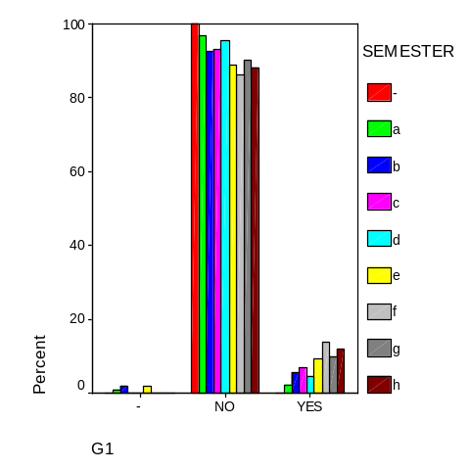
Fig. 2 Prior experience on e-Learning courses.

Figures 3a through 3c, show that the students which are familiar with e-Learning and have experience of use have a positive attitude towards the electronic teaching of a course.
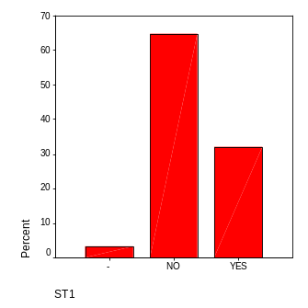  Fig. 3a  is the replacement of a traditional course with an electronic one possible?  Familiarization with e-Learning=NO,  on line course experience=NO | 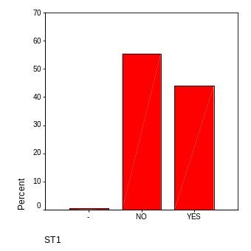  Fig. 3b  is the replacement of a traditional course with an electronic one possible?  Familiarization with e-Learning=YES,  on line course experience=NO | 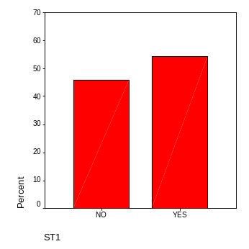  Fig. 3c  is the replacement of a traditional course with an electronic one possible?  Familiarization with e-Learning=YES,  on line course experience=YES
According to [7], Greece has population 10.688.058 and 9.305.700 cellular phone users (approximately 87%, Greece holds the 37th position between 223 Countries). Thus, the majority of active and potential students are familiar with wireless mobile services. This familiarization, can lead to the assimilation of the virtual University wireless services.

REQUIREMENTS OF WIRELESS SERVICES
The basic requirements of the wireless services can be categorized according to the demanding applications. These categories are:

- Coverage range
- User capacity
- Data rates
- Mobility
- Energy consumption
- Service quality
- Transmission direction
- Spectrum usage

Coverage range
The wireless network coverage range can be classified with regard to distance between transmitter and receiver. This distance varies from a few meters to thousands of kilometers. Body Area Networks (BANs) covers distances of few meters (e.g. from cell phone to headset), Personal Area Networks (PANs-simple cable replacement, e.g. communication between PC and mouse) with distances approximately 10 meters, WLANs (Wireless Local Area Networks) that cover ranges up to 300m, Cellular systems with cell radius from 500m to 30km, FWAS (Fixed Wireless Access services, e.g. standard telephony to many distance users) with coverage 100m to several tens of kilometers and satellite systems that offer coverage more that 1000 kilometers[8].

User capacity
User capacity is a key concept and represents that number of users that can be served simultaneously from the same cell or the same transmitting system. In cellular systems, the system capacity depends on the cell size and the distance between cells that using the same set of frequencies if we assume that each Base Station transmits at the same power level [9].

Data rates
The transmission rate is measured in bit per second or bps. This rate is different for every application category. For speech communication the needed rate is between 5kbps and 64kbps. Elementary data rates are between 10kbps and 100kbps including rates for dial-up type services. High speed services like in 3G and beyond cellular networks require rates from 0.5Mbit up to 100Mbps. A real time video transmission (uncompressed) with specifications 320 x 200 pixel frame, 256 color depth (8 bit per color) and 25 frames per second requires transmission rate of 320 x 200 x 8 x 25 = 12.8Mbps.

Mobility
The mobility profile of each user affects the signal quality while is moving inside and outside of network coverage. The velocity in combination with the number of the mobile users creates new requirements for the quality of service, bandwidth management, time response communication systems (e.g. BS-Base station, MSC- (Mobile Switching Center), etc.

Energy consumption
It is known that mobile units operate on batteries and so energy must be saved. Energy concepts are critical for the design of a cellular network especially when basic stages are under development such as amplifier design, coding, modulation, etc. Understanding the tradeoff between performance and energy consumption can help us study the system design in terms of energy constraints [10]. Energy consumption is the main restrictive factor in the amount of functionality in advanced mobile devices such as PDAs[11].

Service quality
Service quality represents the system capability to guarantee the requested transmission rate for a selected service. The connection dropping probability is also a significant metric for the system service quality.

Transmission direction
Due to the restricted system capacity, propagation conditions, interference signals, etc, modern communication systems use smart antennas for beamforming [12] programming. Thus, every antenna array can target the transmitting beam to a specific location and for a specific part of users.

Spectrum usage
Spectrum usage is the most critical aspect of wireless systems. The allocated channels belong to a set of frequency bands and each set can support a specific data rate. The number of users is increasing and in the same time the available bandwidth remains constant and so new method must be applied in order to use it efficiently. New technology devices support high frequency operations and promise new advanced services in combination with the available bandwidth.

TECHNICAL CHALLENGES

Spectrum limitations
The available spectrum is limited so that the same frequencies have to be reused in different locations. The cellular network is a good example. In this network the whole coverage area is divided into smaller service areas called cells (fig.4). A base station is placed in the center of each cell for servicing a number of mobile devices. Cells A through G use different frequencies in order to avoid undesired interference. This set of cells called sector. The sit of cellular sectors define the frequency reusability and network capacity. A number of pair frequency channels (uplink/downlink) are assigned to each cell in the same sector. The challenge is to design efficient channel allocations schemes in order to manage effectively the available bandwidth. The basic statistical metrics for evaluating the network performance is the blocking probability (unsuccessful new call attempts) and dropping probability (dropped calls due to unsuccessful hand-off).

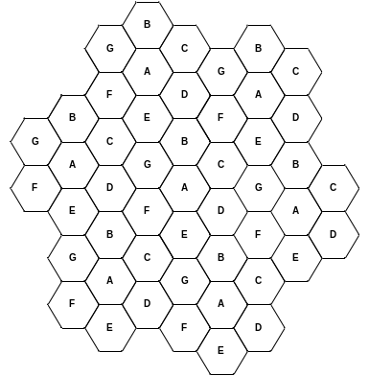 | 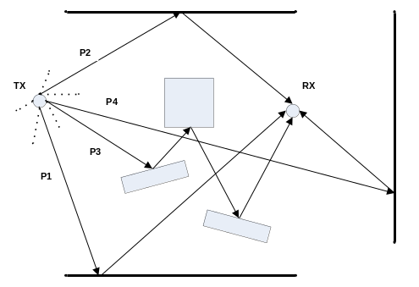
Fig 4. Cellular network structure | Fig 5. Multipath propagation

Multipath propagation
In most cases there is not light of site between the transmitter and receiver. Due to physical or artificial obstacles the transmitted signal is traveling using different paths (fig. 5). All the multipath components can not be distinguished by the receiver. The different phases of the received signals can cause constructive or destructive interference. Maintaining good communications with the existing multipath propagation conditions (fading phenomenon, etc) is very difficult.

Quality of service
One of the most important aspects of a cellular network is that a certain number of calls will fail to establish an initial connection. We can state two measures for dealing with unsuccessful call attempts: the never serviced new calls, and the delayed successful calls (waiting for initial connection). As we mentioned before the connection dropping probability is also a significant metric for the system service quality. The service quality in the busy period of the day may be expressed as the grade of service [9] or quality of service (QoS). Two requirements such as blocking probability and call establishment delay can be set in order to measure GoS level or Quality of Service [13]. QoS in multimedia services refers to the delivery time assurance in real time applications. When we evaluate the performance of a cellular network in terms of blocking and dropping probabilities we use the corresponding statistical metrics. When a new call arrival occurs and the network can not allocate a channel then we say that this call is blocked. The blocking probability P_{blocking} is calculated from the ratio
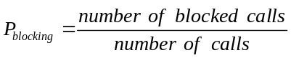
If the received power of each user is high enough, we can make the assumption that the interference from other users can be ignored. The dropping probability Pfc is calculated from the ratio
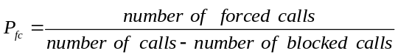

Energy limitation
The power amplifiers of the transmitters have to operate with high efficiency in order to save power. Radio receivers must have high sensitivity. According to GSM standard, a received signal power of -100dBm [8] is acceptable. Maximum transmit power should be used only when required. Designing power efficient communication devices is also a big challenge.

User mobility
The connection continuity of a moving user is a critical issue and relies also on the QoS requirement. Many moving users cause inefficient operation of the BS and MSC. New intelligent methods must be designed in order to support in real time the moving users and to minimize the dropped call probability.

BASIC CHANNEL ALLOCATION STRATEGIES (BANDWIDTH MANAGEMENT) IN CELLULAR NETWORKS
The role of a channel assignment scheme is to allocate channels to cells or mobiles in such a way as to minimize: a) the probability that the incoming calls are blocked, b) the probability that ongoing calls are dropped, and c) the probability that the carrier-to-interference ratio of any call falls below a prespecified value. In literature, many channel assignment schemes have been widely investigated with a goal to maximize the frequency reuse. The channel assignment schemes in general can be classified into three strategies: Fixed Channel Assignment (FCA) [14,15,16,17,18], Dynamic Channel Assignment (DCA) [14,19,20,21,22], and the Hybrid Channel Assignment (HCA) [7,16]. In FCA, a fixed number of channels is assigned to network cells. This method presents low adaptability to dynamically change of network traffic. DCA schemes assign dynamically channels in the network cells according to traffic conditions. Channel allocation methods are based mainly on the Carrier to Noise plus Interference ratio(CNIR). Many DCA variations have been proposed in literature. The traditional DCA schemes searches for an available channel within the initiated cell (new call) and when a channel with CNIR level is found the call is established. Other novel variations have been presented in [24,25,26]. These variations are based in additional criteria such as the least congested cell search (the network tries to assign a channel for a new call in the least congested cell keeping at the same time the network traffic balanced), Best CNR search (finds the strongest signal between Mobile Units and BS for call establishment), round blocking (searches for available channels in all neighbour cells), etc.

CONCLUSIONS
The e-Learning experience influences positively the student’s attitude towards the electronic teaching of a course and so, the development of a virtual University is a very promising idea with regard to new services. The cellular network technology evolution plays the most critical role in the development of mobile multimedia services. Almost anyone is familiar with cellular technology and so, the adoption of new wireless services will not be difficult. The advanced multimedia services require wide bandwidth and assurance of Quality of Service. Supporting such services, the target wireless network must fulfill the above mentioned requirements. The world industry has invested mainly in mobile communications developing multimedia applications through 3G and beyond cellular network. Wi-Fi and WiMAX technology offers high bandwidth but the use in practice is still restricted. The evolution and the implementation of the virtual University are based mainly on the research for answers to the above mentioned challenges.

REFERENCES
[1] Conole, C. (2004), “E-Learning. The Hype and the Reality”, Journal of Interactive Media in Education, ISSN:1365-893X
[2] Pituch Keenan A., Lee Yao-kuei (2004), “The influense of system characteristics on e-learning use”, ELSEVIER, Article in Press
[3] Bacsich P., “Introduction to Virtual Universities and e-Universities”, The Higher Education Academy, August 2004).
[4] Naber, L., Kohle, M. (2002), “If e-Learning is the Answer, what was the Problem?”, Institute for Software Engineering and Interactive Systems, Vienna University of Technology
[5] P. Papazoglou, D. Karras, I. Stavrakas, “The contribution of e-learning aspects in Technological Higher Education in Greece”, Proceedings of WSEAS International Conference on Engineering Education, 2005, Greece),
[6] P. M. Papazoglou, D. A. Karras, “Towards an e-Learning System Development for Technological Higher Education in Greece”, 2nd International Scientific Conference in Information Technology and Quality, 2005, Greece).
[7] http://www.infoplease.com/ipa/A0933605.html, part of Pearson Education)
[8] Molisch F. Andreas, “Wireless Communications”, IEEE Press, 2005
[9] Rappaport T.S., “Wireless Communications principle and practice”, Prentice Hall, 2002
[10] W. Stark, Hua Wang, A. Worthen, S. Lafortune, and D. Teneketzis, “Low-energy
Wireless Communication Network Design,” IEEE Wireless Communications, vol. 9,
no. 4, pp. 60–72, 2002.
[11] Havinga P.J.M., Smit G.J.M., Bos M., “Energy efficient adaptive wireless network design”, The Fifth Symposium on Computers and Communications (ISCC'00), Antibes, France, 2000
[12] Litva, J. and T.K. Lo, “Digital Beamforming in Wireless Communications”, Norwood, MA: Artech House, 1996
[13] M.Salamah and H.Lababidi, “Dynamically adaptive channel reservation scheme for cellular networks”, Elsevier Computer networks, article in press, (2005)
[14] M.Zhang, and T. S. Yum, “Comparisons of Channel Assignment Strategies in Cellular Mobile Telephone Systems”, IEEE Transactions on Vehicular Technology, vol.38,no.4,pp211-215,1989.
[15] W.K. Lai and G.C. Coghill, “Channel Assignment through Evolutionary Optimization”, IEEE Transactions on Vehicular Technology, vol.45,no.1,pp91-96,1996.
[16] V.H. MacDonald, “The cellular Concepts,” The Bell System Technical, Journal, vol.58, pp.15–42, 1979.
[17] S. M. Elnoubi, R. Singh, and S.C. Gupta, “A New Frequency Chan-nel Assignment Algorithm in High Capacity Mobile Communication Sys-tems”, IEEE Transactions on Vehicular Technology, vol. VT-21, no. 3,pp. 125–131, 1982.
[18] Z. Xu and P.B. Mirchandani, “Virtually Fixed Channel Assignment for Cellular Radio-Telephone Systems: A Model and Evaluation”, IEEE International Conference on Communications, ICC’92, Chicago, vol. 2, pp. 1037–1041, 1982.
[19] L.J. Cimini and G.J. Foschini, “Distributed Algorithms for Dynamic Channel Allocation in Microcellular Systems”, IEEE Vehicular Technology Conference, pp.641-644, 1992.
[20] D. C. Cox and D. O. Reudink, “Increasing Channel Occupancy in Large Scale Mobile Radio Systems: Dynamic Channel Reassignment”, IEEE Transanctions on Vehicular Technology, vol.VT-22, pp.218–222, 1973.
[21] E. Del Re, R. Fantacci, and G. Giambene, “A Dynamic Channel Alloca-tion Technique based on Hopfield Neural Networks”, IEEE Transanctions on Vehicular Technology, vol.45, no.1, pp.26–32, 1996.
[22] K.N. Sivarajan, R.J. McEliece, and J.W. Ketchum,“Dynamic Channel Assignment in Cellular Radio”, IEEE 40th Vehicular Technology Confer-ence, pp.631–637, 1990.
[23] T.J. Kahwa and N.D. Georgans, “A Hybrid Channel Assignment Schemes in Large-Scale, Cellular Structured Mobile Communication Sys-tems”, IEEE Transactions on Communications, vol.26, pp 432–438, 1978.
[24] P.M.Papazoglou, D.A.Karras, R.C.Papademetriou, “On new dynamic channel assignment schemes and their efficient evaluation through a generic simulation system for large scale cellular telecommunications”, HERMIS, International Journal of Computer Mathematics and its Applications, 2006
[25] P.M.Papazoglou, D.A.Karras, R.C.Papademetriou, “A dynamic channel assignment simulation system for large scale cellular telecommunications”, International Conference HERCMA 2005
[26] P.M.Papazoglou, D.A.Karras, R.C.Papademetriou, “Evaluating new efficient DCA schemes through a Generic Simulation System for large scale GSM cellular telecommunications”, International Conference, IASTED-ASM 2006

